**Heavy duty floor weighing scale**

|  |  |  |
| --- | --- | --- |
| **Description** | **Requirement** | **Supplier’s Offer** |
| Various weighing capacity | 1000 kg, 1500 kg, 2000 kg, 3000 kg, 5000 kg |  |
| Different platform sizes | 1m x 1m, 1.2m x 1.2m, 1.5m x 1.5m, 2m x 2m & customized sizes |  |
| Rechargeable battery and 240v AC power |  |  |
| RED led Display |  |  |
| Strong ABS housing |  |  |
| Display | counting facility |  |
| Industrial grade mild steel structure with powder coated finish. |  |  |
| High quality IP67, approved OIML alloy steel load cells. |  |  |
| Fully adjustable feet with non-slip rubber base |  |  |
| Temperature Rise Class |  |  |

[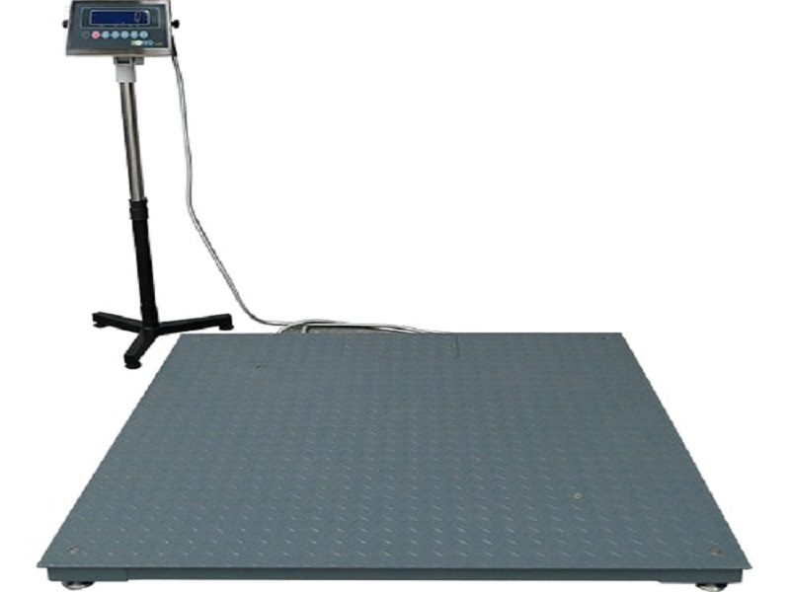](http://www.gulfscales.net/wp-content/uploads/Heavy-duty-Floor-scale.jpg)